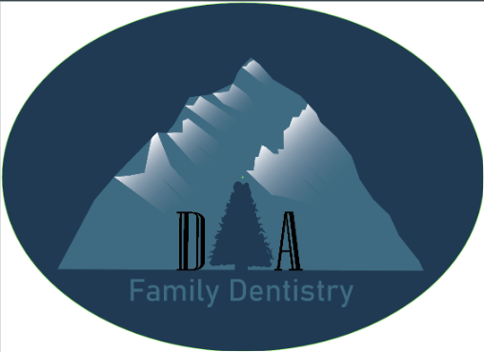

This first logo is a great logo to use sparingly. It was the first one that I created for the Family Tree Dental practice. With your current sign, we see an elaborate background behind the text of “David A Allen”, and I figured I would take that design and simplify it. The mountain behind uses the initials of the owner of the practice and can even use the tree as an A for the complete initials to be seen. However, it has a lot going on and may not be widely used in other instances. Additionally, when I showed you this, you were more interested focusing on the family tree dentistry part of the name rather than the name of the doctor.

So, I decided to simplify quite a bit for the next logo which can be used on simple documents, signage or even the side of the building.

This logo is what I cam up with. It removes the actual mountain from the background but keeps the tree itself. It also removes the D and A and replaces it with the F and A. This was a depiction that you focused on after the first iteration, asking that it be focused more on the name of the practice rather than you as the doctor. This was in hopes to keep patients attached to the practice rather than the doctor, especially for if the practice is bought out at retirement. This logo uses the tree as an actual tree to portray the name of the business. And with it being simpler, it allows for it to be used in a wider sense. However, I did feel like it was repetitive to have the Family Tree Dentistry under the FTD so I decided to simplify it further and just use the FTD. This is still recognizable and leaves the name still present while creating a fun easter egg for others to find in your logo.

It is also important to note that these logos can be adapted with a background color pretty easily if the color schemes isn’t what you are looking for. It would be a simple fix and not hard to do. Hopefully, this is helpful to show exactly how these logos can be used and that you will be able to benefit from the creation of them.